How to use 4G
The 4G interface of device support TCP Client Mode.
Step 1:
Please check whether or not your reader with 4G, if not, please buy 4G reader first. Then you should insert SIM card to device first, you should make sure this SIM card support 4G LTE Net.
Step 2: Open 4G interface.
Open ReaderSoft file path
Double click ReaderSoft.exe logo.
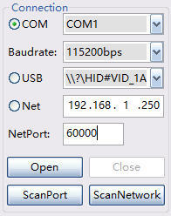, Choose connect port, such as COM, USB or Net(RJ45)
Then click Open button, it will show like this picture
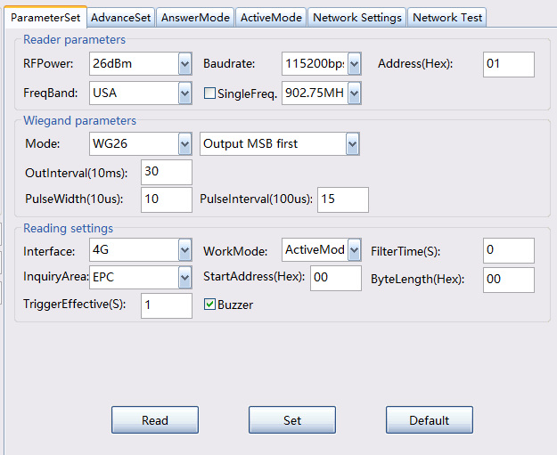
Select Interface as 4G, and WorkMode as ActiveMode.
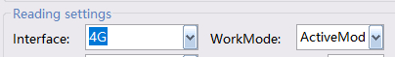
After set over, click Set button, if show paramters error, pls click read button first then set .
Then set 4G parameter at Network Settings
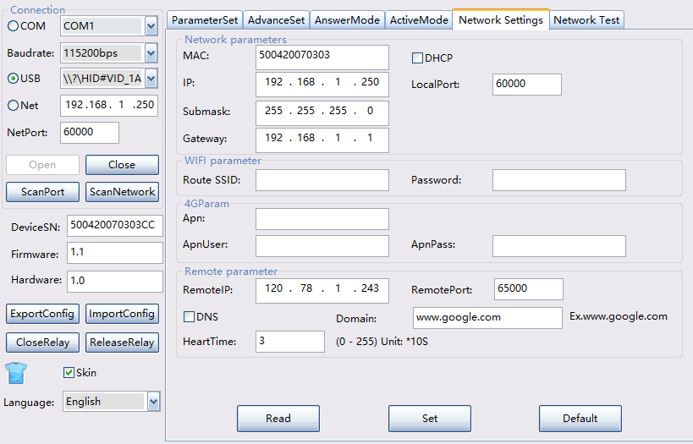
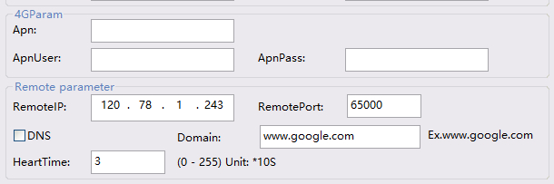
Apn and ApnUser and ApnPass is provided by ISP, many countries ISP do not need these parameters. If you want to sure, please call your local ISP phone to check it.
RemoteIP is TCP Server IP.
RemotePort is TCP Server Listening Port.
DNS mean open server domain mode, if open DNS, please input domain name such as www.google.com not with http:// , and RemoteIP is invalid. And it not support HTTPS encrypt web.
After set over, click Set button, if show paramters error, pls click read button first then set .
For reduce data package and speed up transmission, you can set filterTime, set up zero mean open filterTime.
ParamSet -> FilterTime
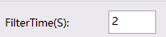
After set these parameters, 4G is opened now. First use ,you will wait 60S or you can restart reader first and wait 20S.

You can use SDK->TcpServer soft to test wifi or use NetwortTest table
[Waring] If you test 4G, your IP must is Public network IP not local LAN IP.
Or you can test in your server PC.
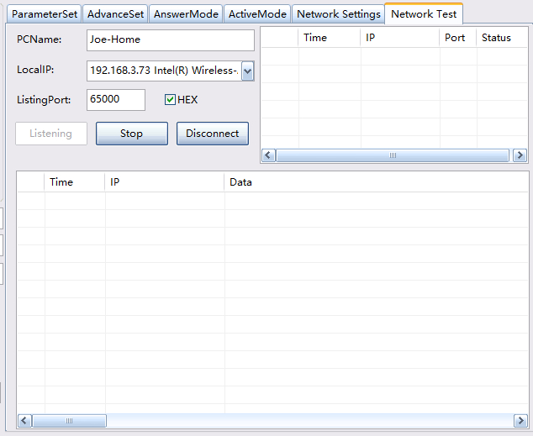
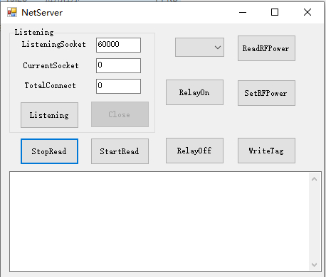
ListeningSocket is 4G param of RemotePort.

If you want to develop soft, use SDK->TcpServer file path to develop
Or SDK->Android->TcpServerDemo
Or SDK->QT_Linux->TcpServer
Or SDK->NodeJS->TcpServer
Or SDK->RaspberryPi->TcpServer

